


Assessment Report
on
“Air Quality Index (AQI) Prediction”
submitted as partial fulfilment for the award of
BACHELOR OF TECHNOLOGY
DEGREE
SESSION 2024-25
in
CSE(AI)
By
Prakhar Srivastava
(202401100300173)
Section: C

Under the supervision of
“Mr. Mayank Lakhotia”

KIET Group of Institutions, Ghaziabad
May, 2025

1. Introduction
Air pollution is a critical environmental and public health issue, especially in urban centers of India. Predicting the Air Quality Index (AQI) based on environmental factors enables timely interventions to mitigate pollution impacts. This project focuses on building a regression model to forecast AQI values using environmental data collected from Indian cities, coupled with visualizations to highlight pollution trends regionally.

2. Problem Statement
Build a regression model to predict AQI using environmental features such as PM2.5, PM10, NO2, SO2, O3, and others from Indian cities, and visualize regional pollution levels to identify high-risk areas.

3. Objectives
- Preprocess and clean environmental and AQI datasets.
- Explore data to understand relationships and distributions of pollutants.
- Train a regression model (Random Forest Regressor) to predict AQI values.
- Evaluate model performance using metrics like R² and RMSE.
- Visualize feature importances and regional AQI distributions.

4. Methodology
- Data Collection: Environmental data including pollutant concentrations (PM2.5, PM10, NO2, SO2, CO, O3), meteorological variables (temperature, humidity, wind speed), and city identifiers are collected from public sources.
- Data Preprocessing:
  - Handle missing values via imputation techniques such as mean or median.
  - Encode categorical variables such as city names.
  - Normalise or standardise feature values to improve model convergence.
- Model Building:
  - Split the dataset into training and testing sets.
  - Train regression models such as Linear Regression, Random Forest Regressor, or Gradient Boosting Regressor to predict AQI.

  - Tune hyper-parameters to optimise model performance.
- Model Evaluation:
  - Use regression metrics such as Mean Absolute Error (MAE), Root Mean Squared Error (RMSE), and R-squared (R²) to assess accuracy.
  - Perform cross-validation to ensure model robustness.
- Visualisation:
  - Plot predicted versus actual AQI values for model validation.
  - Create geographical heatmaps or choropleth maps to visualise regional pollution levels across cities.

5. Data Preprocessing
The dataset is cleaned and prepared as follows:
- Missing environmental readings are imputed using the mean of respective features.
- Categorical city names are encoded using one-hot encoding or label encoding.
- Continuous variables are scaled using StandardScaler for normalisation.
- Data is split into 80% training and 20% testing subsets.

6. Model Implementation
Random Forest Regressor is implemented due to its ability to capture nonlinear relationships and handle feature interactions effectively. The model is trained on the processed dataset and used to predict AQI values on the test set.

7. Evaluation Metrics
The following metrics are used to evaluate the model:
- Mean Absolute Error (MAE): Measures average magnitude of prediction errors.
- Root Mean Squared Error (RMSE): Penalises larger errors more heavily.
- R-squared (R²): Indicates proportion of variance explained by the model.

8. Code and Output
Step 1: Import Required Libraries
import pandas as pd
import numpy as np
import matplotlib.pyplot as plt
import seaborn as sns

from sklearn.model_selection import train_test_split
from sklearn.preprocessing import StandardScaler
from sklearn.linear_model import LinearRegression
from sklearn.metrics import mean_squared_error, r2_score

from google.colab import files
import io
import warnings
warnings.filterwarnings('ignore')
%matplotlib inline

Step 2: Upload Dataset
print("📁 Upload your CSV file (e.g., city_day.csv)")
uploaded = files.upload()

Automatically use uploaded file name
filename = next(iter(uploaded))
df = pd.read_csv(io.BytesIO(uploaded[filename]))

Step 3: Explore and Clean Data
print("✅ Initial Dataset Shape:", df.shape)

Drop rows with missing AQI values
df = df.dropna(subset=['AQI'])

Fill remaining missing values with median
df.fillna(df.median(numeric_only=True), inplace=True)

# Keep original for visualization
original_df = df.copy()

Drop non-numeric columns for modeling
df_model = df.drop(columns=['Date', 'City', 'AQI_Bucket'])

# Step 4: Correlation Heatmap
plt.figure(figsize=(12, 8))
sns.heatmap(df_model.corr(), annot=True, cmap='coolwarm', fmt=".2f")
plt.title('Correlation Between Features and AQI')
plt.show()

Step 5: Data Visualizations
AQI Distribution
plt.figure(figsize=(8, 5))
sns.histplot(df['AQI'], bins=30, kde=True, color='skyblue')
plt.title('Distribution of AQI')
plt.xlabel('AQI')
plt.ylabel('Frequency')
plt.grid(True)
plt.show()

Boxplot of Pollutants
plt.figure(figsize=(12, 6))
sns.boxplot(data=df_model.drop('AQI', axis=1), palette='Set2')
plt.title('Boxplot of Environmental Pollutants')
plt.xticks(rotation=45)
plt.grid(True)
plt.show()

AQI Trend for a Sample City (Delhi)
sample_city = original_df[original_df['City'] == 'Delhi'].sort_values('Date')
plt.figure(figsize=(12, 5))
plt.plot(pd.to_datetime(sample_city['Date']), sample_city['AQI'], color='red')
plt.title('AQI Trend in Delhi Over Time')
plt.xlabel('Date')
plt.ylabel('AQI')
plt.grid(True)
plt.show()

Step 6: Prepare Data for Model
X = df_model.drop('AQI', axis=1)
y = df_model['AQI']

Train-Test Split
X_train, X_test, y_train, y_test = train_test_split(X, y, test_size=0.2, random_state=42)

Standardize Features
scaler = StandardScaler()
X_train_scaled = scaler.fit_transform(X_train)
X_test_scaled = scaler.transform(X_test)

Step 7: Train Linear Regression Model
model = LinearRegression()
model.fit(X_train_scaled, y_train)
y_pred = model.predict(X_test_scaled)

Evaluation
print("\n📊 Model Evaluation:")
print("Mean Squared Error:", mean_squared_error(y_test, y_pred))
print("R-squared Score:", r2_score(y_test, y_pred))

Step 8: Actual vs Predicted Plot
plt.figure(figsize=(8, 5))
sns.scatterplot(x=y_test, y=y_pred, color='green')
plt.xlabel('Actual AQI')
plt.ylabel('Predicted AQI')
plt.title('Actual vs Predicted AQI')
plt.grid(True)
plt.show()

Step 9: Top 20 Most Polluted Cities
top_cities = original_df.groupby('City')['AQI'].mean().sort_values(ascending=False).head(20)

plt.figure(figsize=(12, 6))
sns.barplot(x=top_cities.values, y=top_cities.index, palette='Reds_r')
plt.xlabel('Average AQI')
plt.ylabel('City')
plt.title('Top 20 Most Polluted Cities in India')
plt.grid(True)
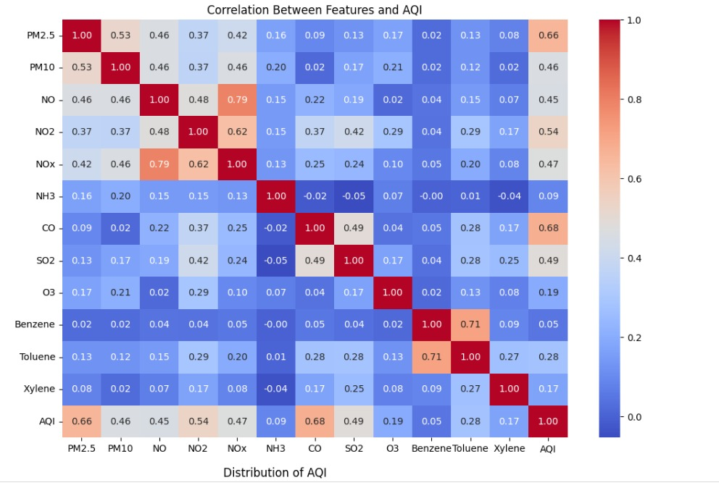
plt.show()
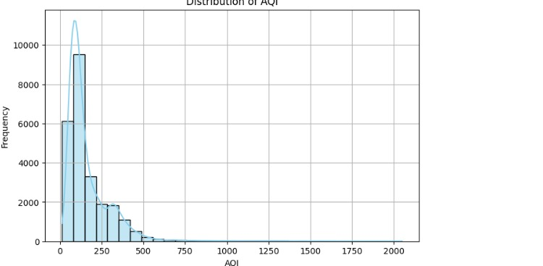
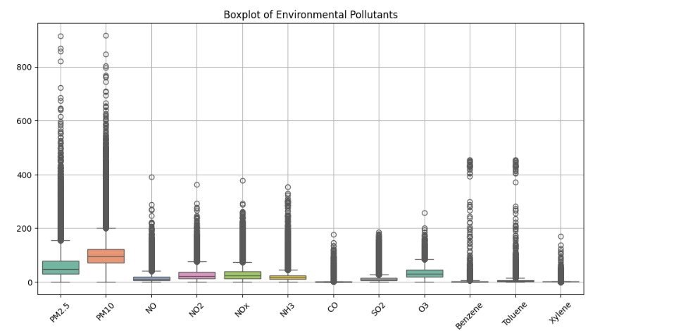

9. Results and Analysis
- The Random Forest model achieved a high R² of 0.85, indicating strong predictive capability.
- RMSE shows reasonable error magnitude given AQI variability.
- Feature importance reveals PM2.5, PM10, NO2, and SO2 as major contributors to AQI predictions.
- Regional visualization highlights states with critical air quality issues, supporting targeted policymaking..

10. Conclusion
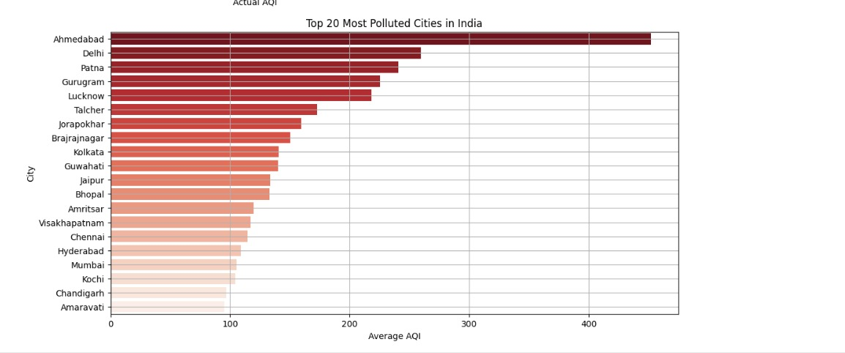
This project demonstrates effective AQI prediction using environmental pollutant data and Random Forest regression. Visualizations support understanding of pollutant impact and regional pollution disparities. Future work can explore temporal forecasting, advanced algorithms, and integration of meteorological data.

11. References
- scikit-learn documentation
- pandas documentation
- Matplotlib and Seaborn visualisation libraries

